|  |  |  |
| --- | --- | --- |
|  |  | problem sheet  05/11/2020 |

# ACTIVITY 1

Write a python program to find the volume of a cone.

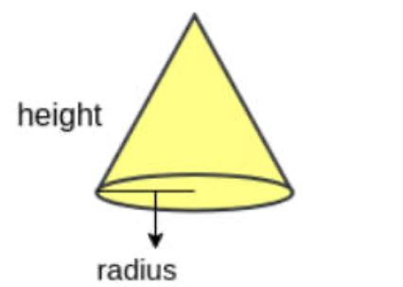

ALGORITHM:

1. Start
2. Import math to use the value of pie .
3. Read height and radius as the height and radius of the cone respectively from user.
4. Evaluate vol = (1/3)pie*(radius^2)*height

(vol=(1/3)*(math.pi*(radius**2)*height)) as volume of cone

1. Print the vol as volume of the cone.
2. stop

PROGRAM:

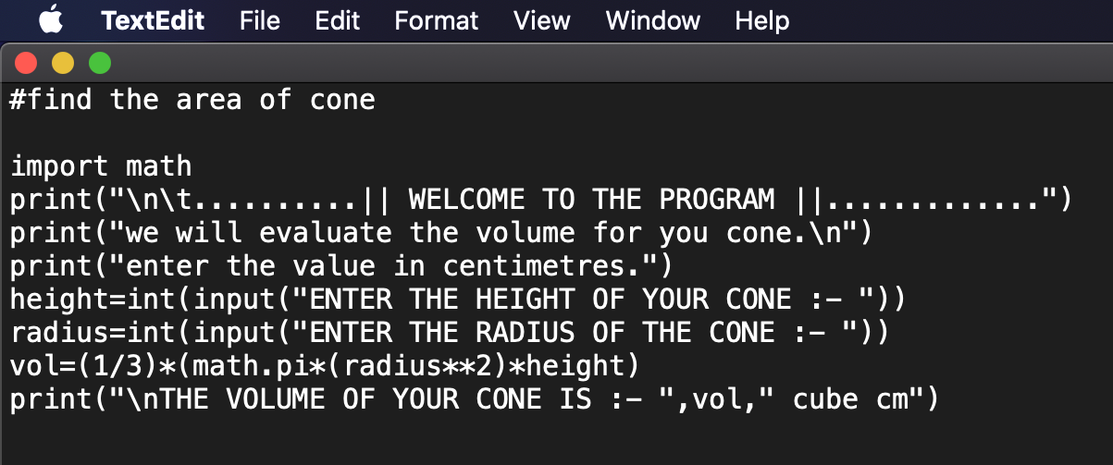

OUTPUT:

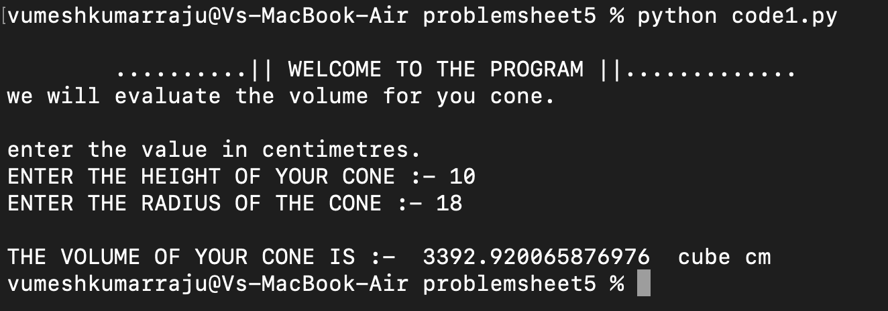

# ACTIVITY 2

Write a python program to find the volume of a cylinder.

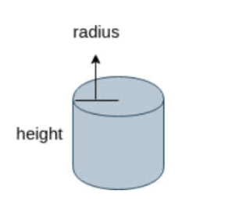

ALGORITHM:

1. Start
2. Import math to use the value of pie .
3. Read height and radius as the height and radius of the cylinder respectively from user.
4. Evaluate vol = pie*(radius^2)*height

(vol=math.pi*(radius**2)*height) as volume of cylinder

1. Print the vol as volume of the cylinder.
2. stop

PROGRAM:

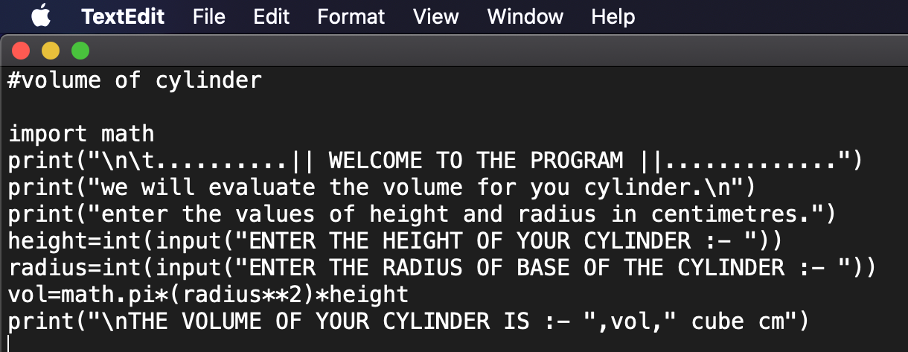

OUTPUT:

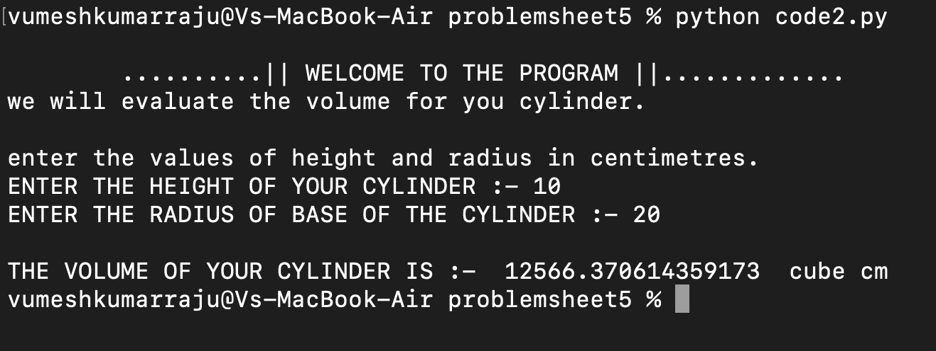

# ACTIVITY 3

Write a python program to convert Celsius into Fahrenheit.

ALGORITHM:

1. Start
2. Read c_temp as the temperature in Celsius .
3. Evaluate f_temp=((c_temp*9)/5)+32 as the temperature in Fahrenheit.
4. Print f_temp as the converted temperature in Fahrenheit.
5. stop

PROGRAM:

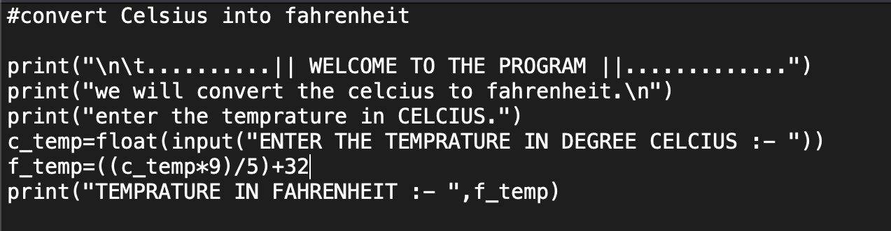

OUTPUT:

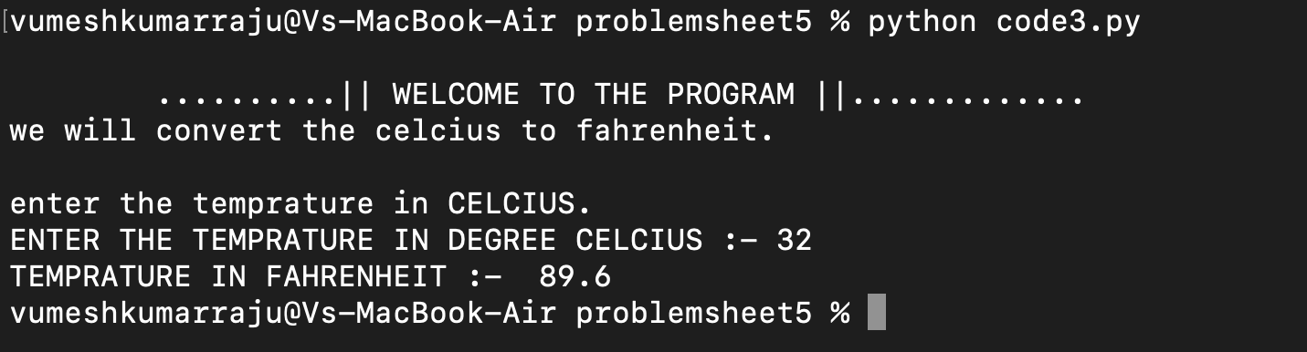

# ACTIVITY 4

Write a python program to find the simple interest

ALGORITHM:

1. Start
2. Read p, r, t as the principal amount, rate of interest, time from user.
3. Evaluate si = p*r*t/100 as the simple interest.
4. Print si as the simple interest.
5. Stop

PROGRAM:

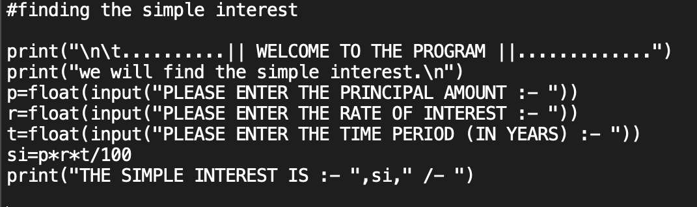

OUTPUT:

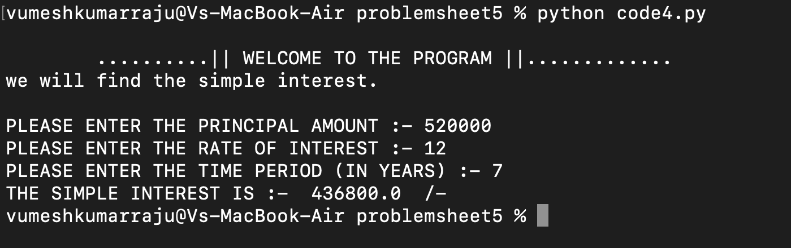

# ACTIVITY 5

Write a python program to check weather number is disarium number.

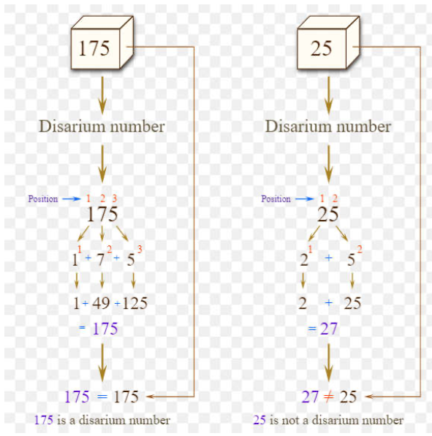

ALGORITHM:

1. Start
2. Read num as the integer to be checked.
3. Initialize count=0, sum=0, num1=num, num_check=num
4. Count the number of digits in num
   * + 1. While num not equals to 0(num1!=0)
          1. Update count = count+1
          2. num1=integer part of num1/10
5. for the value of i between count to 0
   * + 1. evaluate dig = num%10(reminder when num is divided by 10).
       2. Update sum=sum+dig^i(sum=sum+dig**i)
       3. num=integer part of num/10
       4. i = i-1
6. check if sum equals to num_check(sum==num_check) then print number is a disarium number

else print the number is not a disarium number.

1. Stop

PROGRAM:

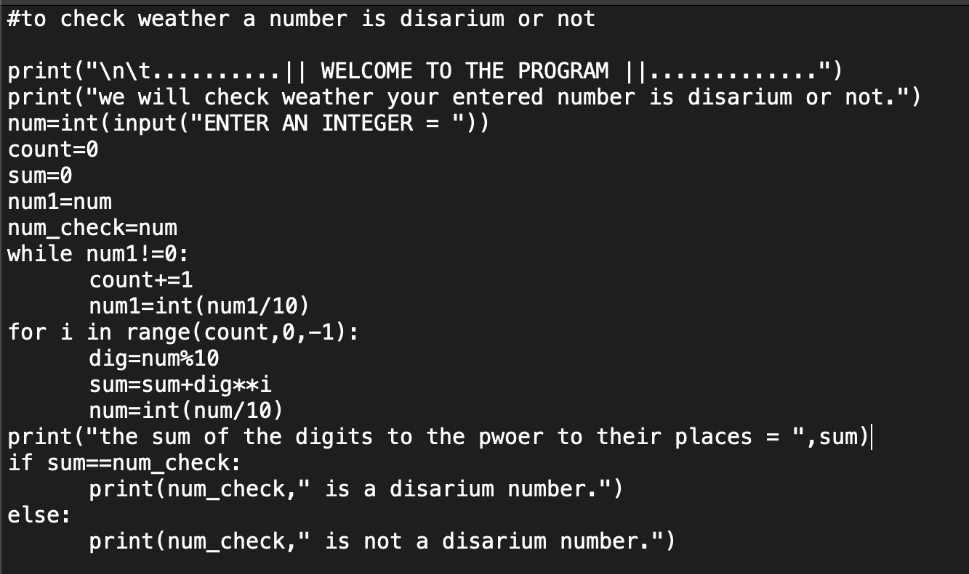

OUTPUT:

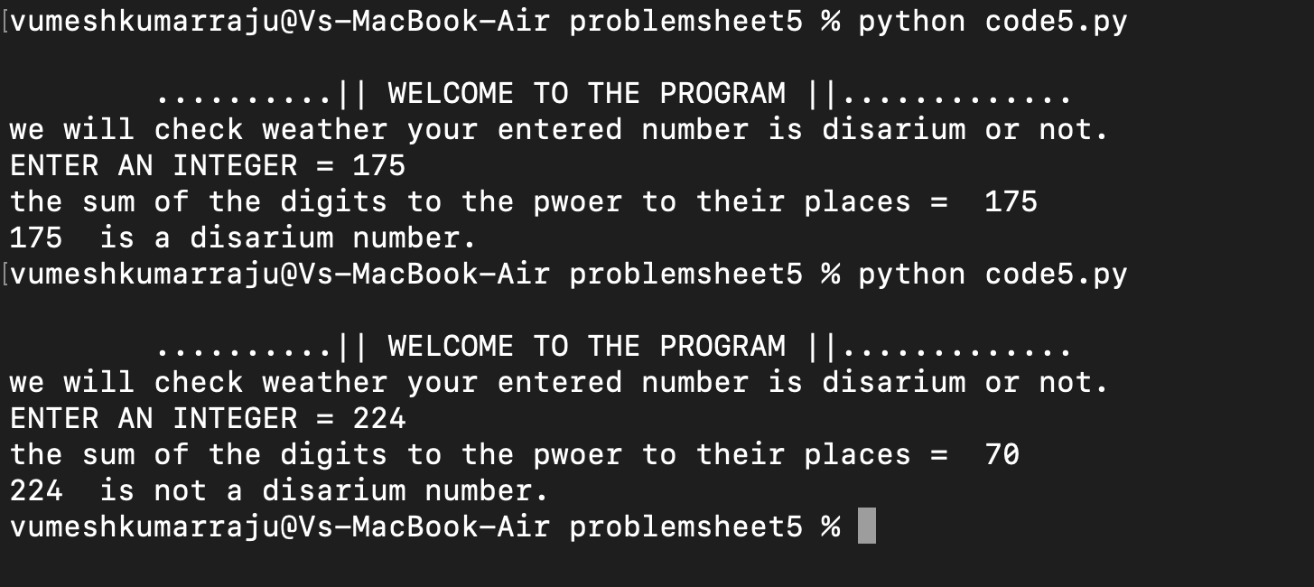

# ACTIVITY 6

Write a python program to print all the disarium number between a given range.

ALGORITHM:

1. Start
2. Read a and b as the starting range and ending range respectively.
3. For the value of x between a to b+1
   * + 1. Initialize num=x,count=0, sum=0, num1=num
       2. Count the number of digits in num

While num not equals to 0(num1!=0)

* + - * 1. Update count = count+1
        2. num1=integer part of num1/10
      1. for the value of i between count to 0

evaluate dig = num%10(reminder when num is divided by 10).

Update sum=sum+dig^i(sum=sum+dig**i)

num=integer part of num/10

i = i-1

* + - 1. if sum==x then print x end with space.

1. Stop

PROGRAM:

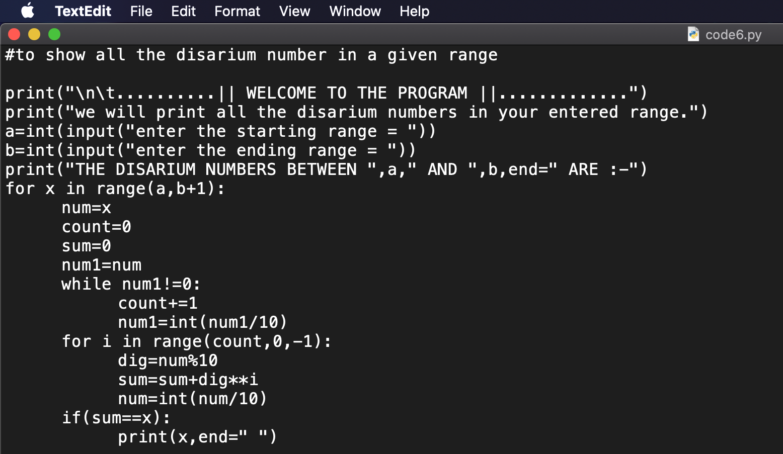

OUTPUT:

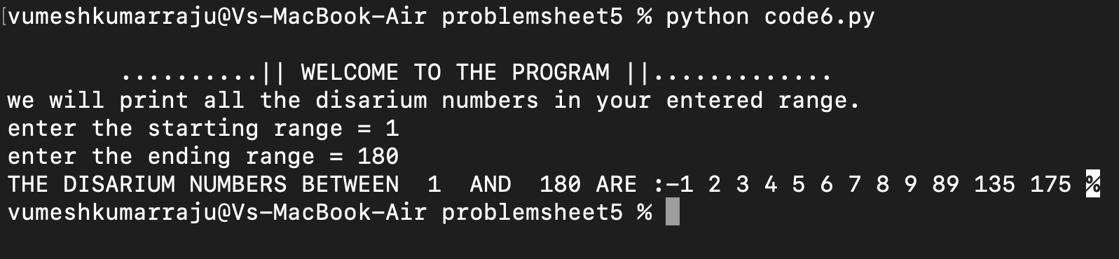

# ACTIVITY 7

Write a python program to check weather a number is harshad number.

A number is said to be harshad number if it is divisible by the sum of the digit.

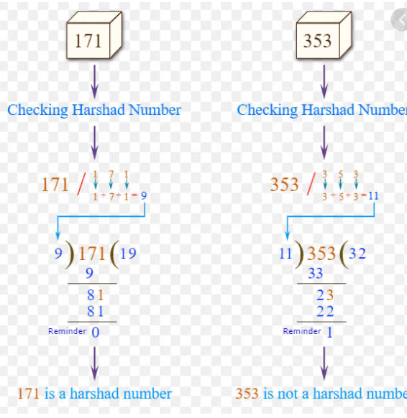

ALGORITHM:

1. Start
2. Read num a the integer to be checked.
3. Initialize num_copy=num, sum=0
4. While num not equals to zero (num!=0)
   1. Evaluate dig=num%10(reminder when num divided by 10)
   2. Update sum=sum+dig
   3. Update num=integer part of num/10(num=int(num/10))
5. If num_copy%sum==0(reminder is 0 when num_copy is divided by sum) print num_copy is a harshad number

Else print num_copy is not a harshad number.

1. Stop

PROGRAM:

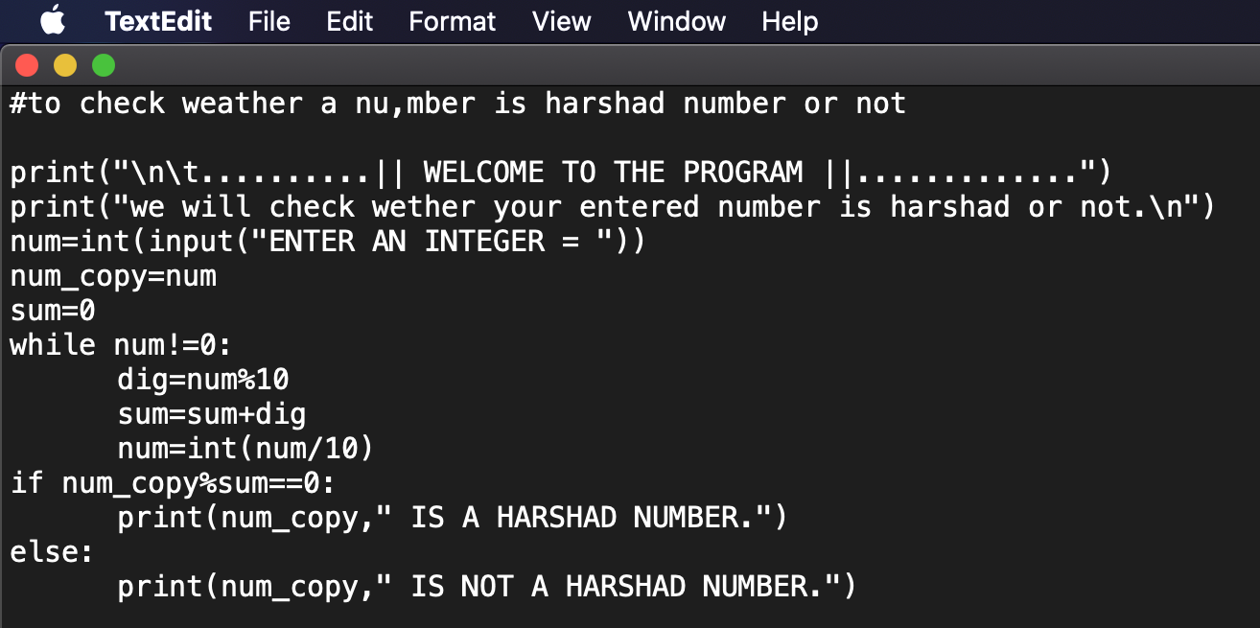

OUTPUT:

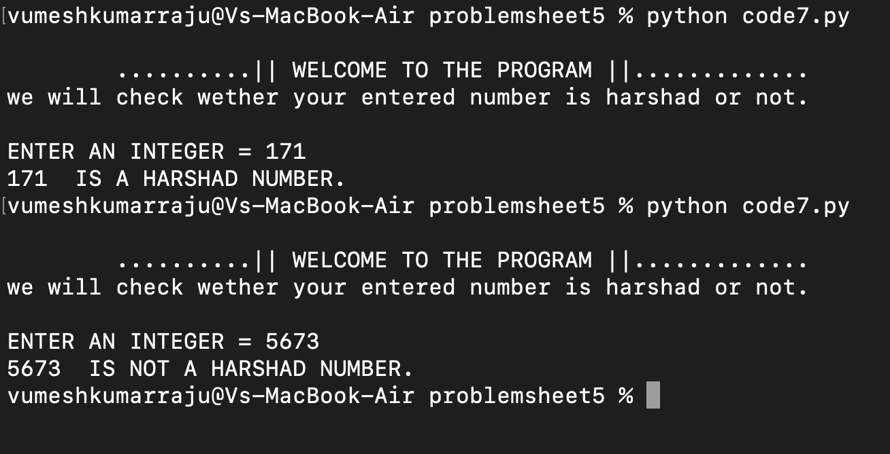

# ACTIVITY 8

Write a python program to check weather a number is pronic number.

* A number is said to be pronic number if it is a product of two consecutive numbers.

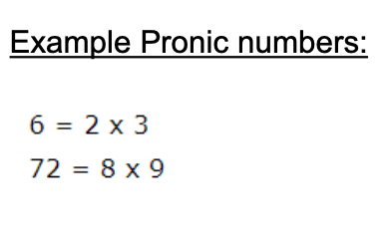

ALGORITHM:

1. Start
2. Read num as the number to be checked.
3. Initialize k=0,fact=1,i=1
4. While fact <=num
   * + - 1. if fact is equal to num(fact==num)

* print i, symbol '*', i+1, symbol" = " and fact.
* print num is a pronic number.
* k=2
  + - * 1. update i=i+1

1. if k equals to 0(k==0) print num is not a pronic number.
2. Stop

PROGRAM:

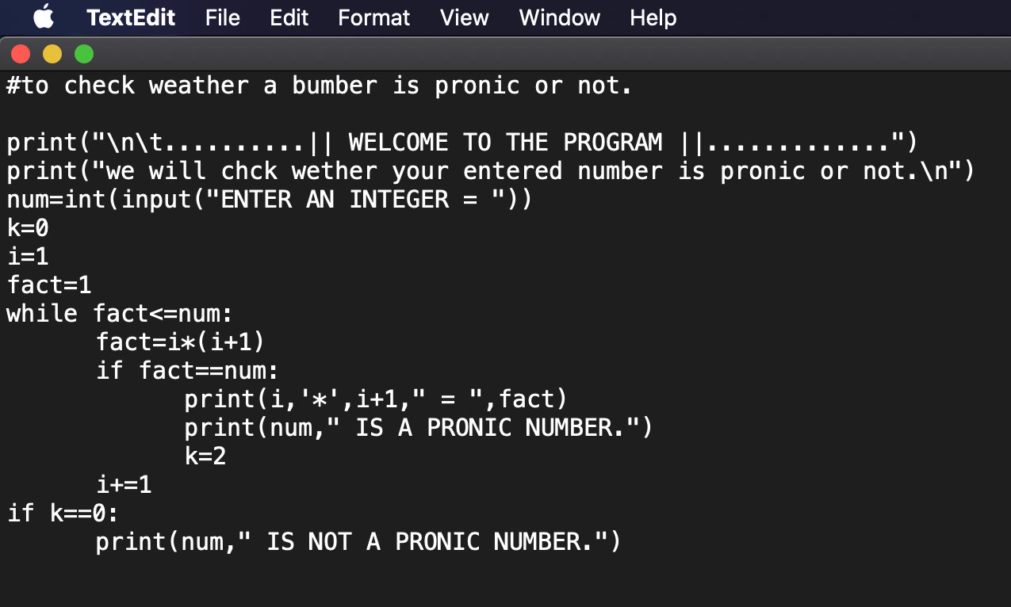

OUTPUT:

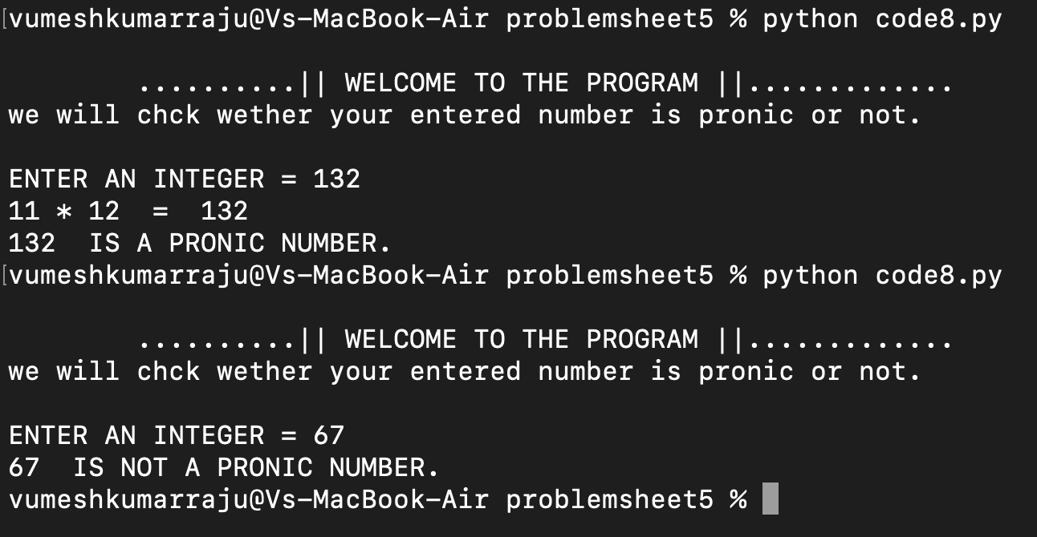

# ACTIVITY 9

Write a python program to print following pattern.

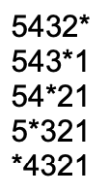

ALGORITHM:

1. Start
2. Read line as the number of lines to be print the pattern
3. For the value of i in between 1 to line+1
   * + 1. For the value of j in between line to 0
          1. If j equals to i (j==i) print '*’ symbol ends with white space

Else print j end with white space

(b)j=j-1 updates after succession of every loop.

(2) print a new line

(3)i=i+1 updates after succession of every loop

1. stop

PROGRAM:

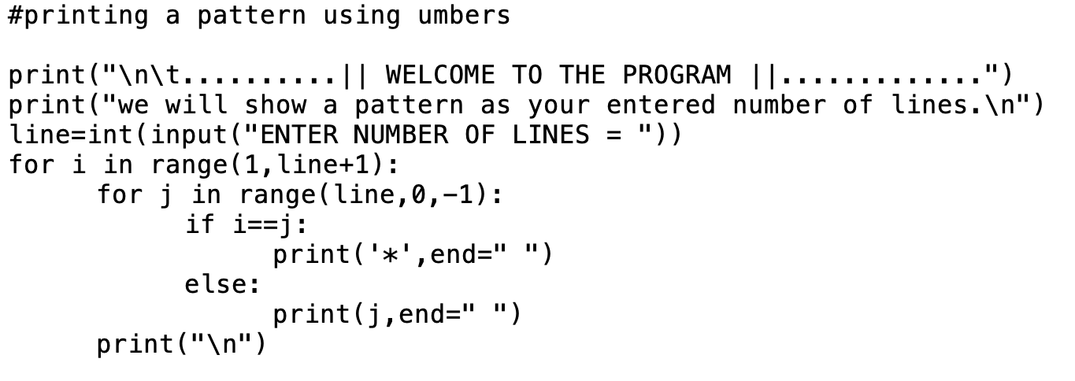

OUTPUT:

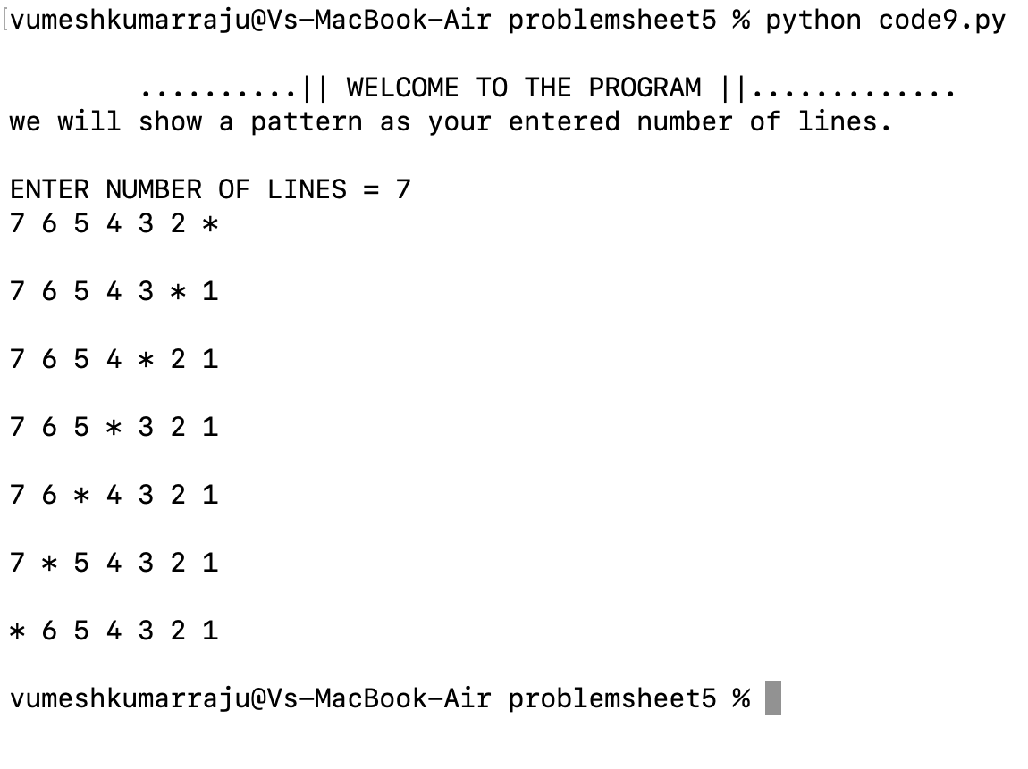

# ACTIVITY 10

Write a python program to print following pattern.

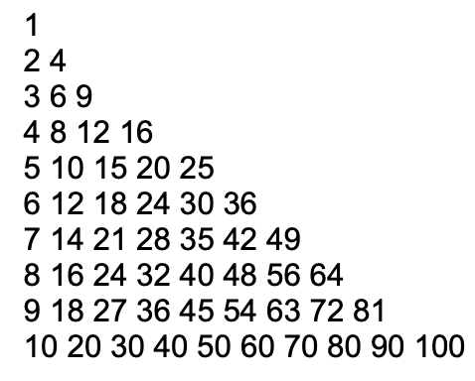

ALGORITHM:

1. Start
2. Read line as number of lines to print the pattern.
3. For the value of i between 1 to line+1
   * + 1. For the value of j between 1 to i+1
          1. Print the value of i*j end with a white space.
       2. Print a new line
       3. i=i+1 after every succession of loop.
4. Stop

PROGRAM:

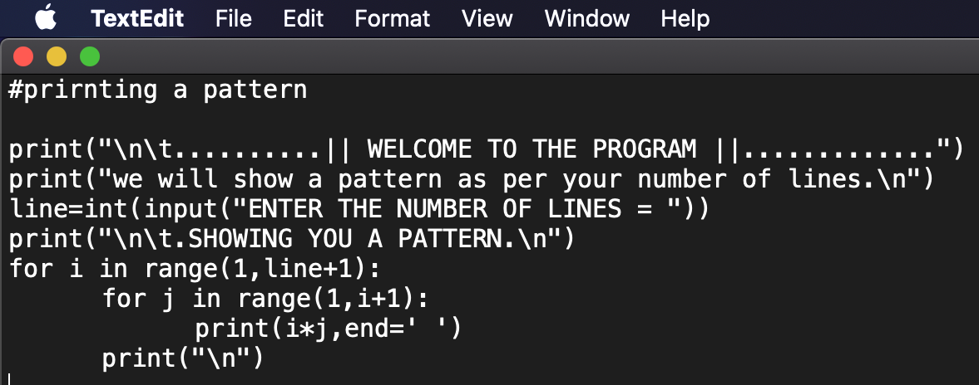

OUTPUT:

